**ECSE 428 Assignment B  
Amee Joshipura (260461226)  
Lilly Tong (260459522)  
  
JUnit Test Cases & Screen shots**

**Test 1  
Test name:** cToP_returns_double_array **Call setup**: cartesianToPolar(3,4) **Expected:** cartesianToPolar() returns a double array

**Fail:**

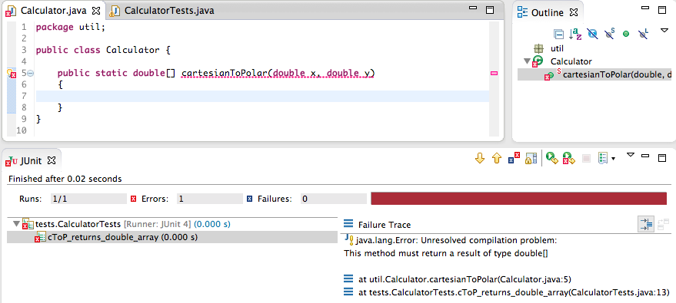

**Succeed:**

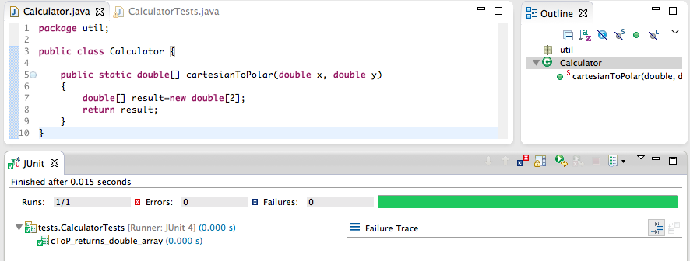

**Test 2**

**Test name:** cToP_inputs_are_zero

**Call setup**: cartesianToPolar(0,0) **Expected:** cartesianToPolar() throws exception with message “One or more inputs are zero!”

**Fail:**  
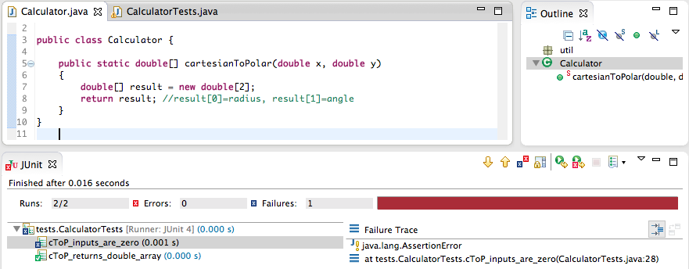

**Succeed:**

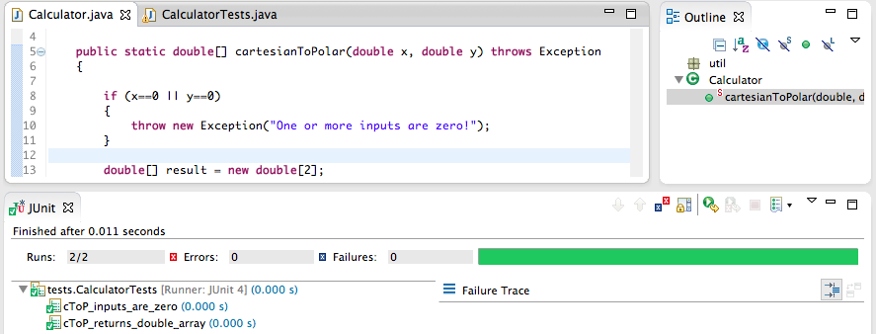

**Test 3**

**Test name:** cToP_inputs_are_nonzero

**Call setup**: cartesianToPolar(3,4) **Expected:** cartesianToPolar() returns [5, arctan(4.0/3.0)]  
  
**Fail:**

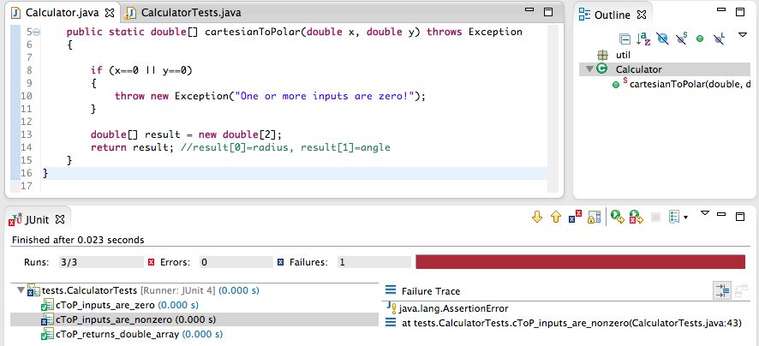

**Succeed:**

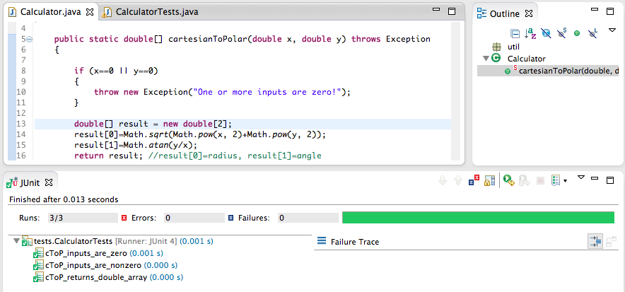

**Test 4**

**Test name:** cToP_contains_negative_input

**Call setup**: cartesianToPolar(3,-4) **Expected:** cartesianToPolar() returns [5, arctan(-4.0/3.0)]  
  
**Succeed:**

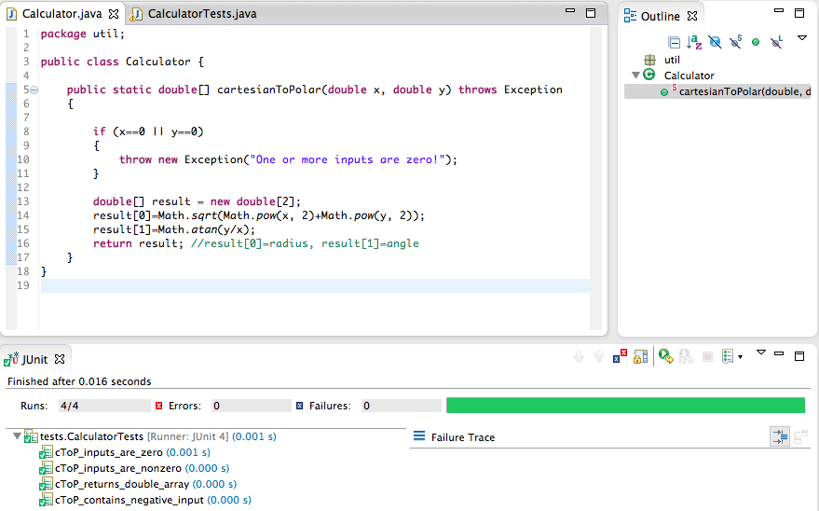

**Test 5**

**Test name:** cToP_inputs_too_large

**Call setup**: cartesianToPolar(10000,-10000) **Expected:** cartesianToPolar() throws exception with message “Inputs too large!”

**Fail:**

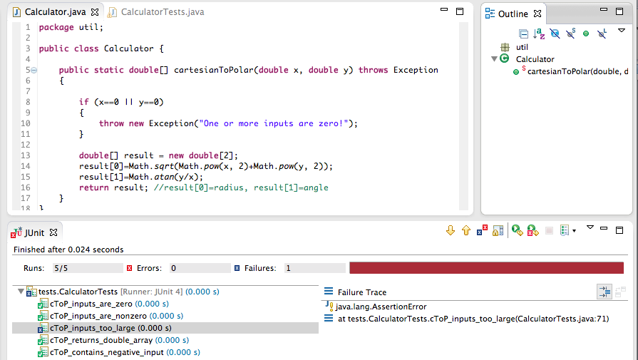

**Succeed:**

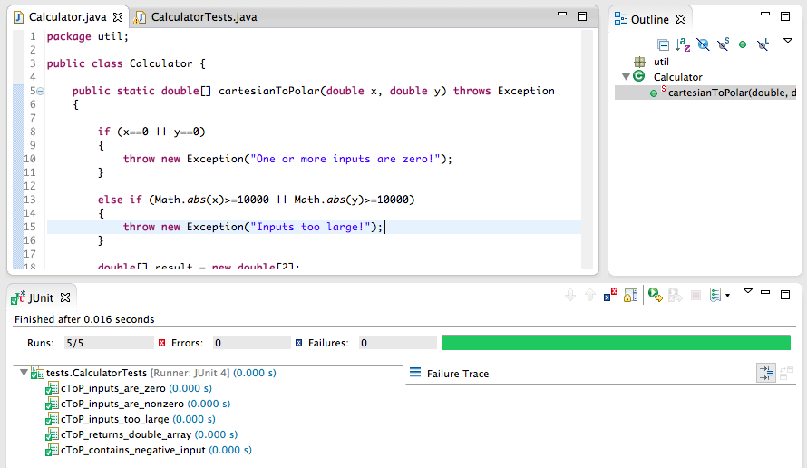

**Test 6**

**Test name:** cToP_inputs_too_small

**Call setup**: cartesianToPolar(0.01,-0.01) **Expected:** cartesianToPolar() throws exception with message “Inputs too small!”

**Fail:**

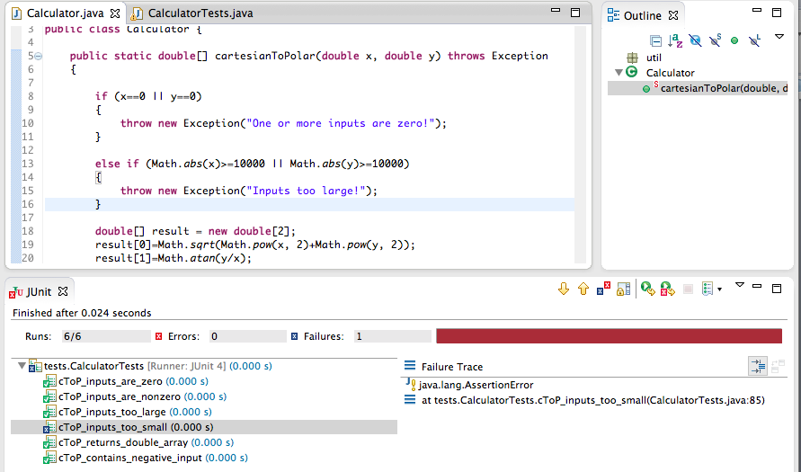

**Succeed:**

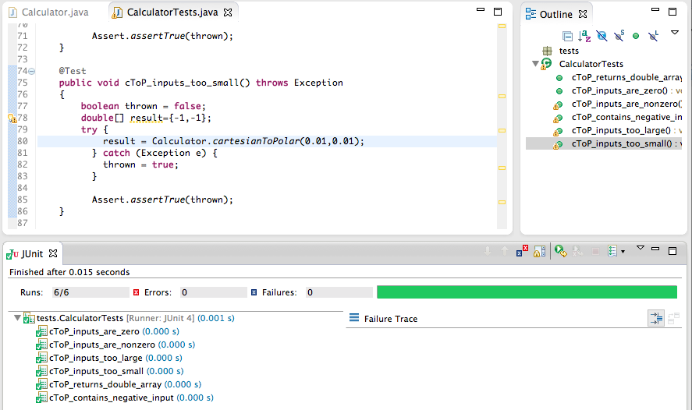

**Test 7**

**Test name:** pToC_returns_double_array **Call setup**: polarToCartesian(3,0.5) **Expected:** polarToCartesian() returns a double array

**Fail:**

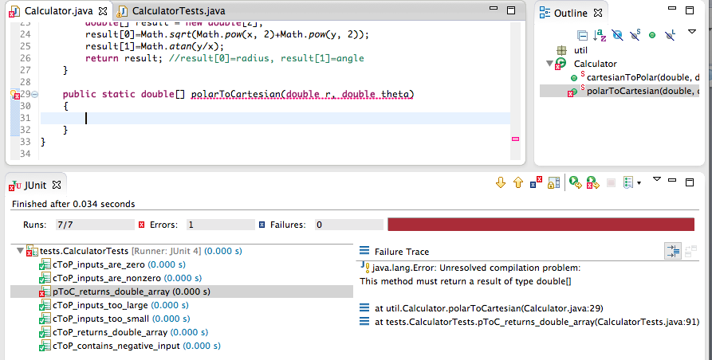

**Succeed:**

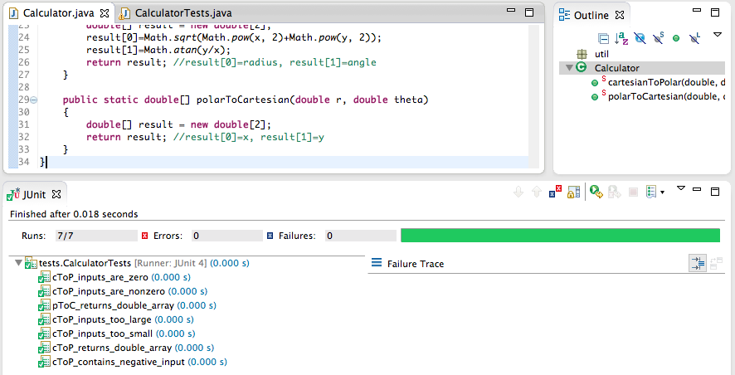

**Test 8**

**Test name:** pToC_inputs_too_large

**Call setup**: polarToCartesian(10000,-10000) **Expected:** polarToCartesian () throws exception with message “Inputs too large!”

**Fail:**

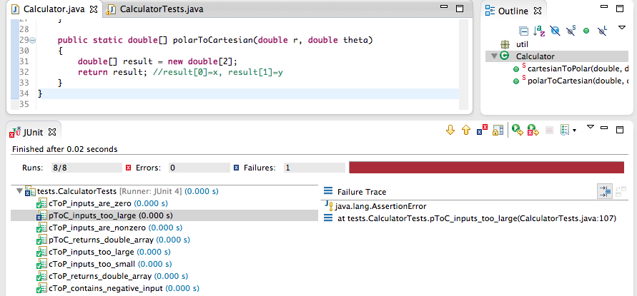

**Succeed:**

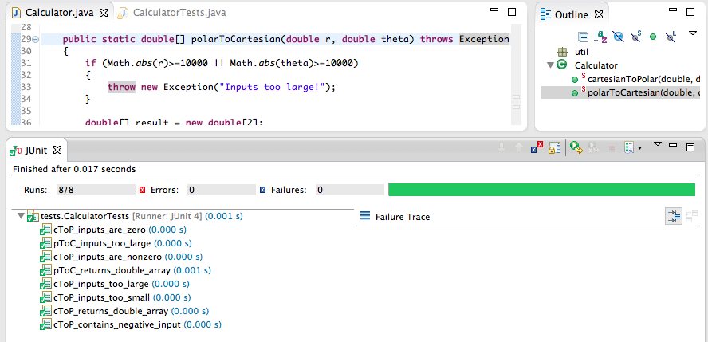

**Test 9**

**Test name:** pToC_inputs_are_nonzero

**Call setup**: polarToCartesian(5,arctan(4/3)) **Expected:** polarToCartesian() returns [3,4]

**Fail:**

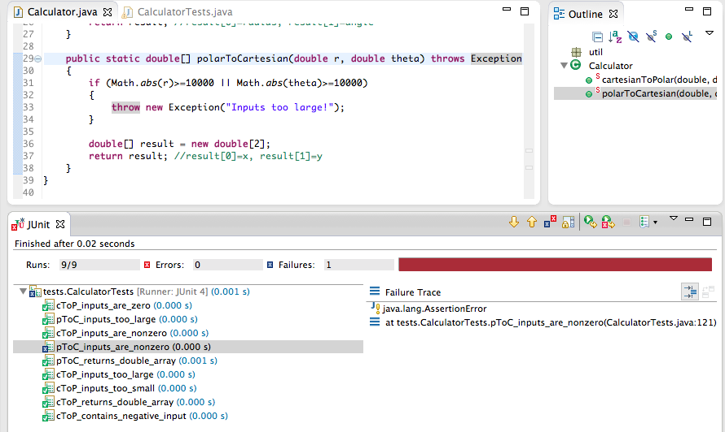

**Succeed:**  
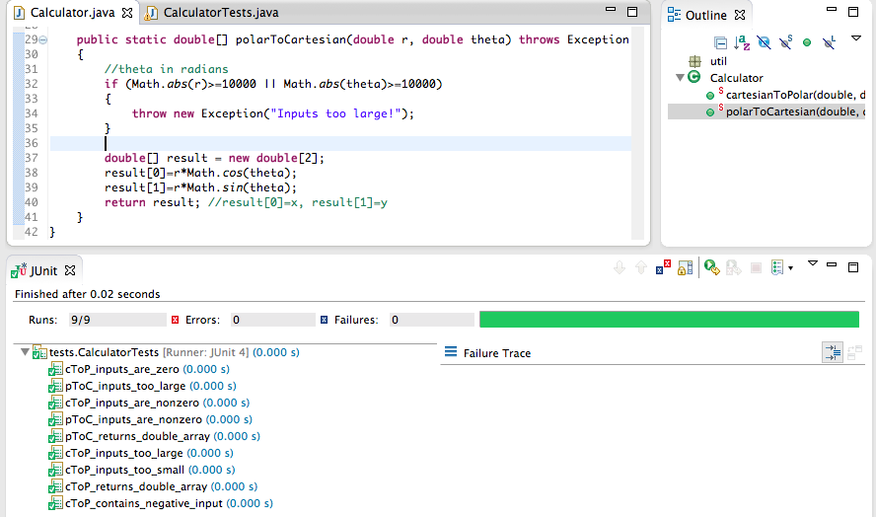

**Test 10**

**Test name:** add2vectors_returns_double_array

**Call setup**: add2vectors(3,4,5,6) **Expected:** add2vectors() returns a double array

**Succeed:**

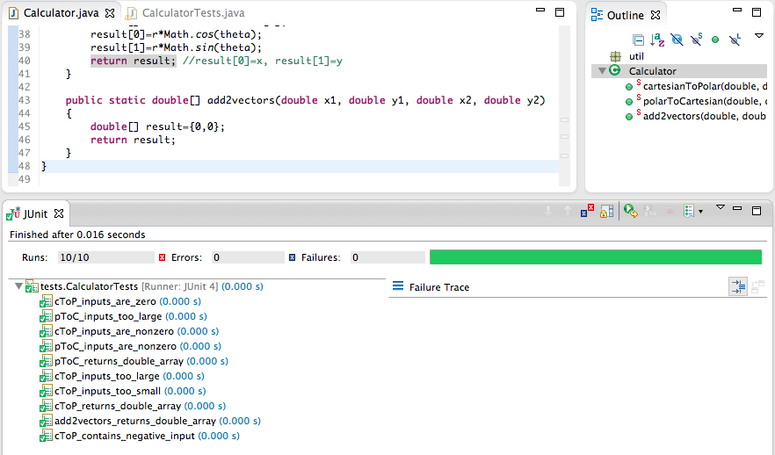

**Test 11**

**Test name:** add2vectors_regular_input

**Call setup:** add2vectors(3,4,5,6)

**Expected:** add2vectors() returns [8,10]  
  
**Fail:**

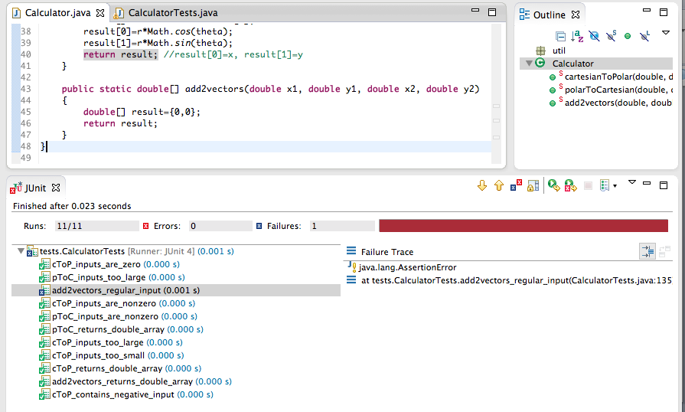

**Succeed:**

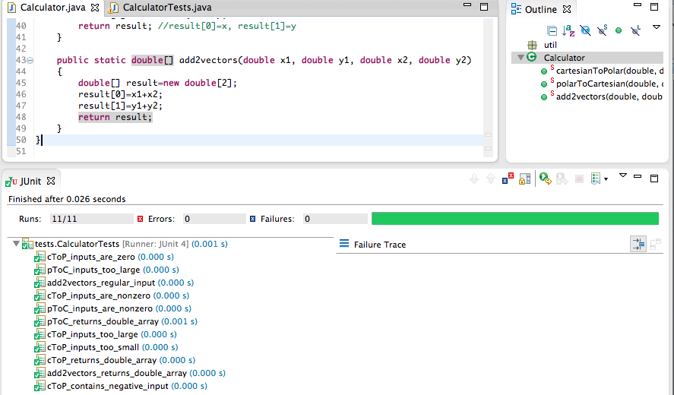

**Test 12**

**Test name:** add2vectors_inputs_too_large

**Call setup**: add2vectors(10000,-10000,10000,-10000) **Expected:** add2vectors() throws exception with message “Inputs too large!”

**Fail:**

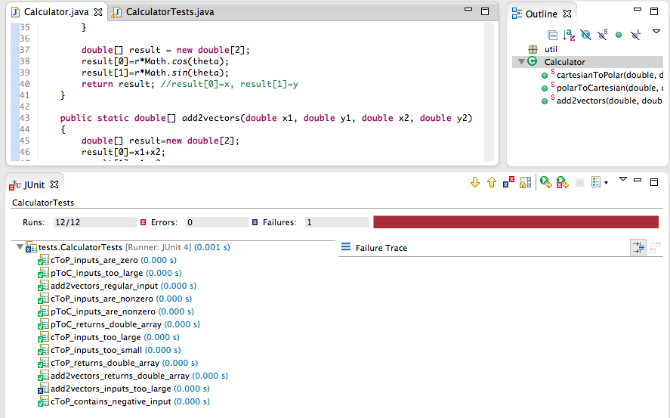

**Succeed:**

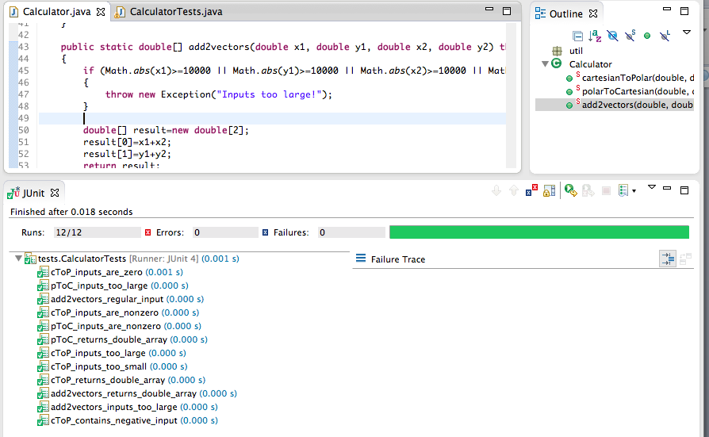

**Test 13**

**Test name:** add3vectors_returns_double_array

**Call setup**: add3vectors(3,4,5,6,7,8) **Expected:** add3vectors() returns a double array

**Fail:**

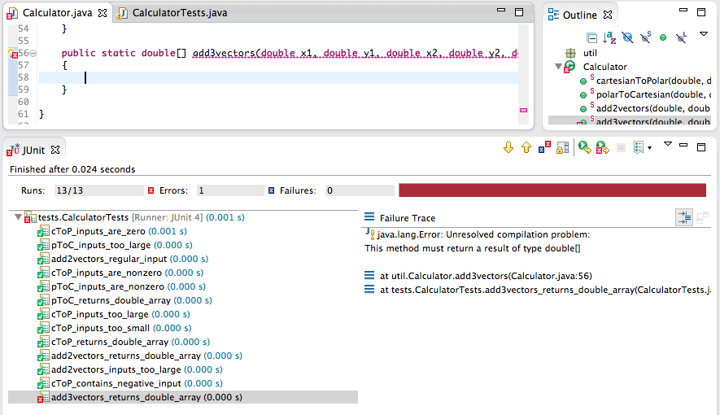

**Succeed:**

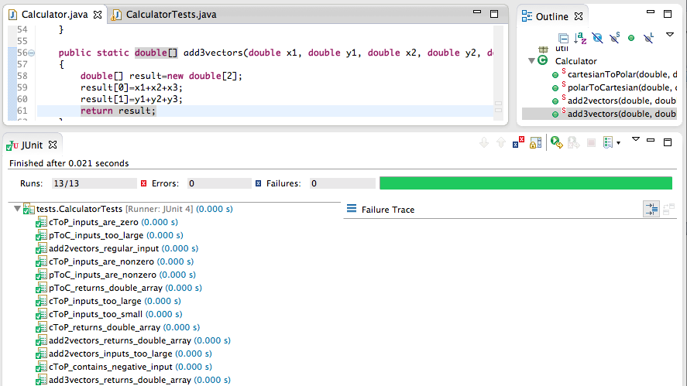

**Test 14**

**Test name:** add3vectors_regular_input

**Call setup:** add3vectors(3,4,5,6,7,8)

**Expected:** add2vectors() returns [15,18]

**Fail:**

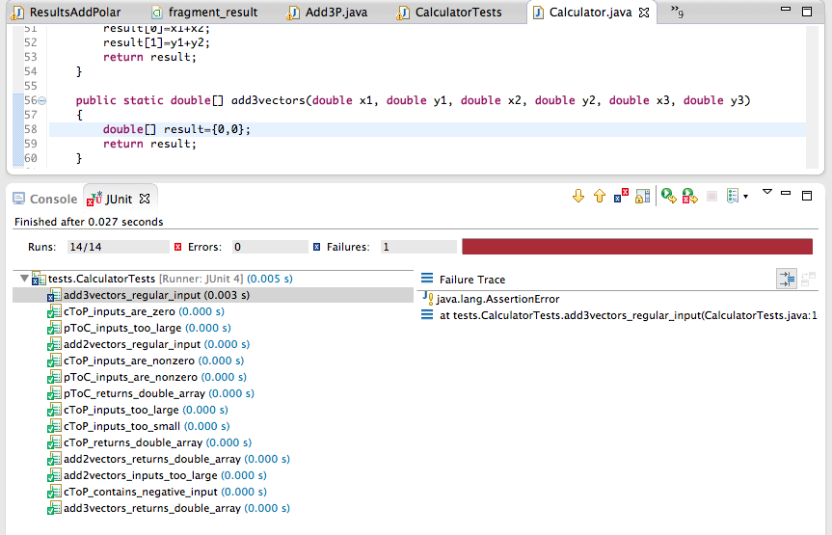

**Succeed:**

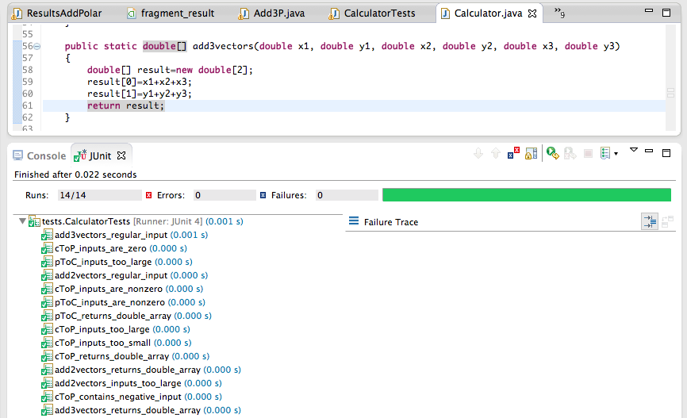

**Test 15**

**Test name:** add3vectors_inputs_too_large

**Call setup**: add3vectors(10000,-10000,10000,-10000,10000,-10000) **Expected:** add3vectors() throws exception with message “Inputs too large!”

**Fail:**

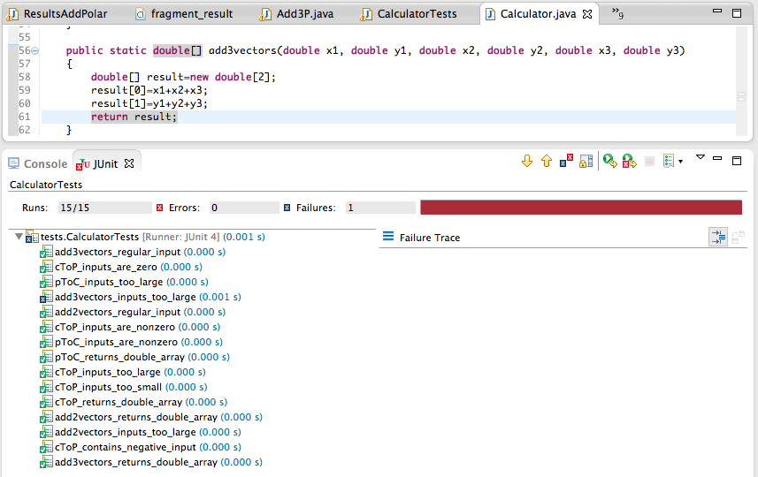

**Succeed:**

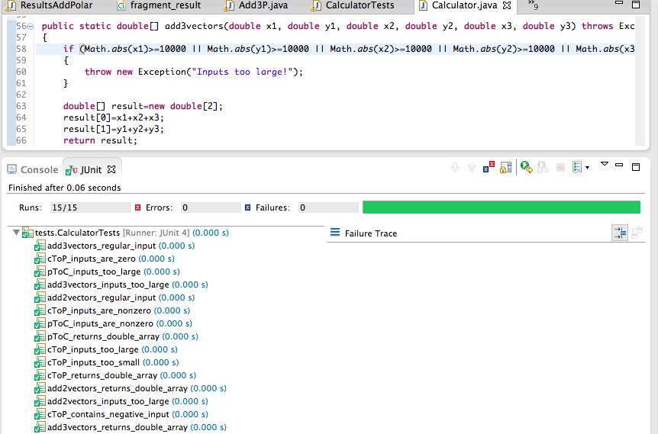

**Test 16**

**Test name:** scalarProduct_regular_input

**Call setup**: scalarProduct(3,4,5,6) **Expected:** scalarProduct() returns a 39

**Fail:**

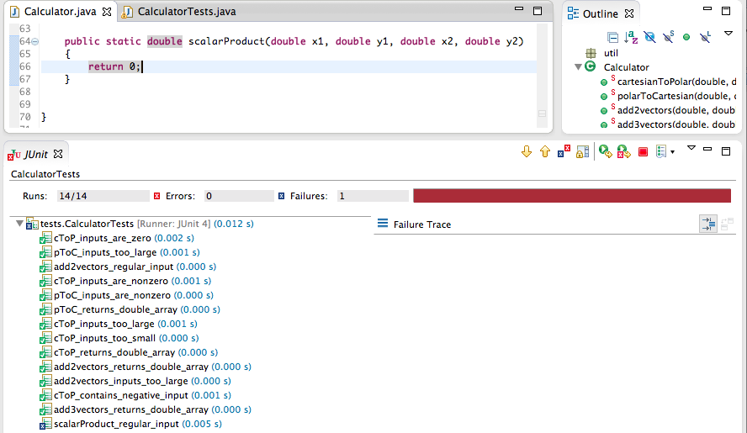

**Succeed:**

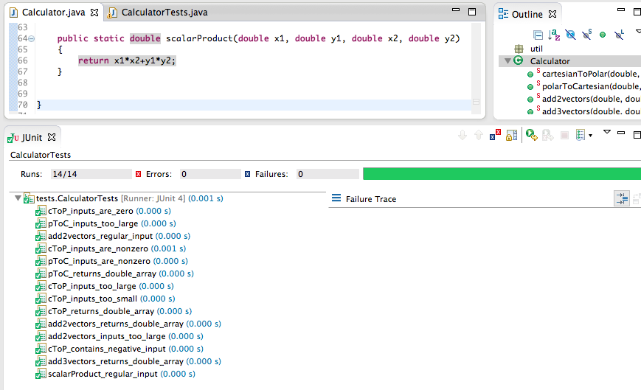

**Test 17**

**Test name:** scalarProduct_inputs_too_large

**Call setup**: scalarProduct(10000,-10000,10000,-10000) **Expected:** scalarProduct() throws exception with message “Inputs too large!”

**Fail:**

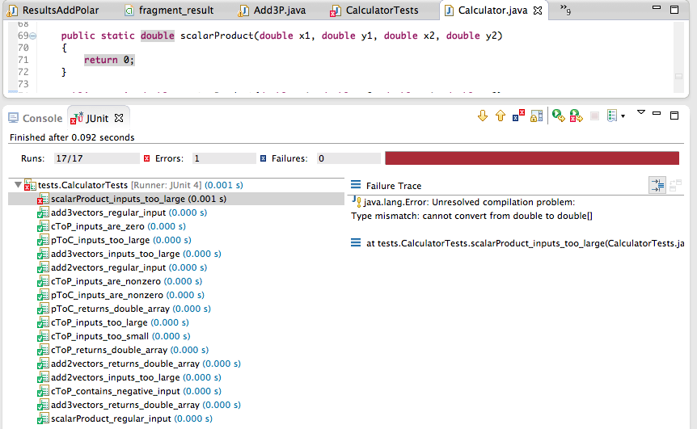

**Succeed:**

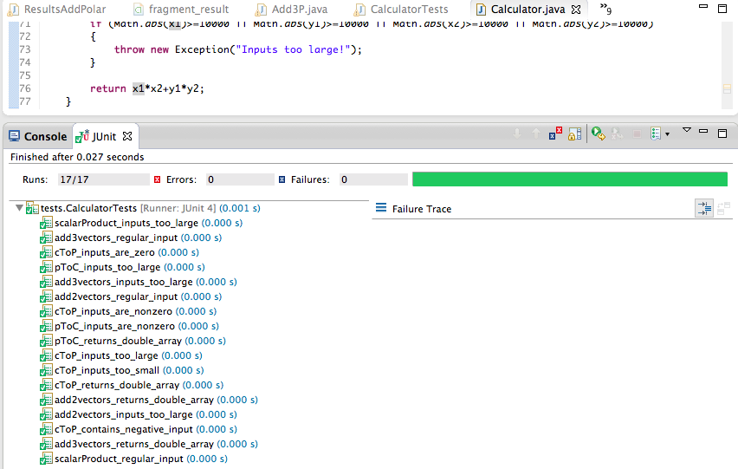

**Test 18**

**Test name:** vectorProduct_regular_input

**Call setup**: vectorProduct(3,4,5,6) **Expected:** vectorProduct() returns a -2

**Fail:**

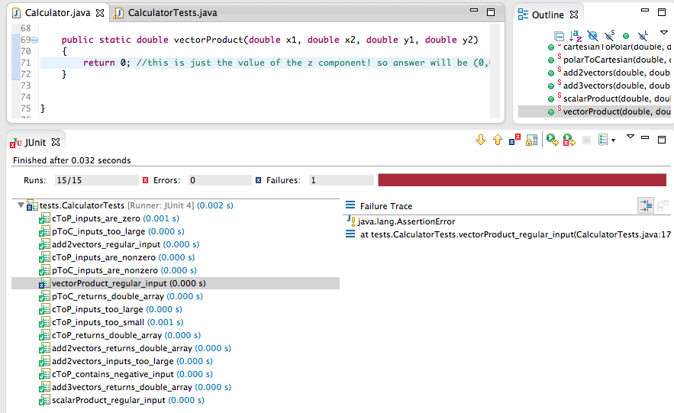

**Succeed:**

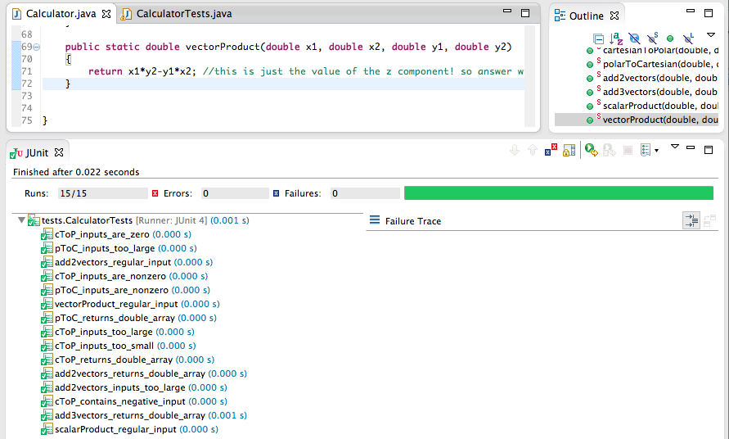

**Test 19**

**Test name:** vectorProduct_inputs_too_large

**Call setup**: vectorProduct(10000,-10000,10000,-10000) **Expected:** vectorProduct() throws exception with message “Inputs too large!”

**Fail:**

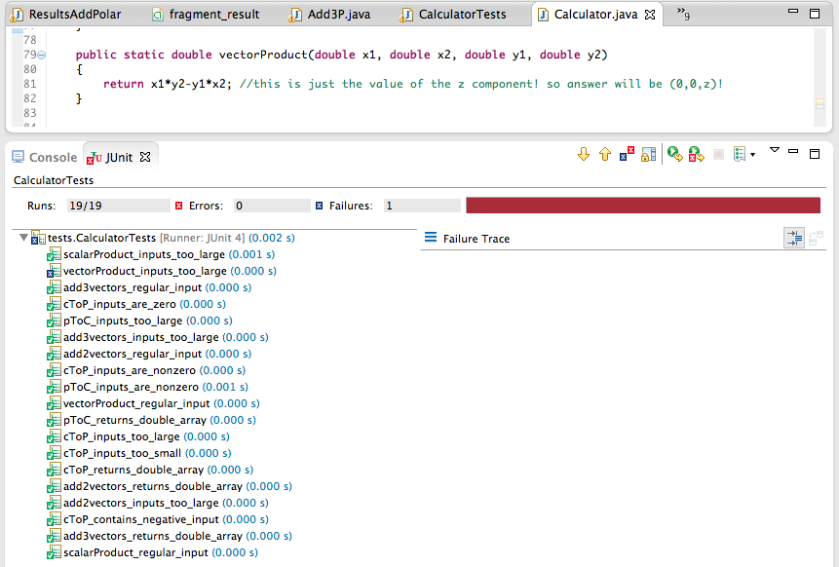

**Succeed:**

